Getting HLM to Properly make MDMs for a 2-Level Model
In HLM 7
1) Make sure both your level 1 and level 2 files are sorted by the level 2 ID.
2) Run the HLM program
3) Under 'file' select 'make new MDM-->stat package input'
4) Select 'HLM2' and press 'okay'
5) Choose your Level 1 and Level 2 files.
6) Choose variables. (Level 2 ID variable is the ID variable. Level 1 ID does not need to be included.)
7) Change "Missing Data?" to yes and "Delete missing data when" to running analyses. (see below)
8) Click on "Save mdmt file". Give it a name.
9) Click "Make MDM"
10) Click "Check Stats". Look it over to make sure everything looks how you want it to. Save the file. (I always save it as "descriptives".)
11) Click "Done"

In HLM 6
1) Make sure both your level 1 and level 2 files are sorted by the level 2 ID and that your variable names do not exceed 8 characters.
2) Run the HLM program
3) Under 'file' select 'make new MDM-->stat package input'
4) Select 'HLM2' and press 'okay'
5) **For input file type, select Anything else (stat/transfer). (You theoretically shouldn't need to do this, but this will avoid some errors.) Put a name in that box with the .mdm extension (e.g., carol.mdm)
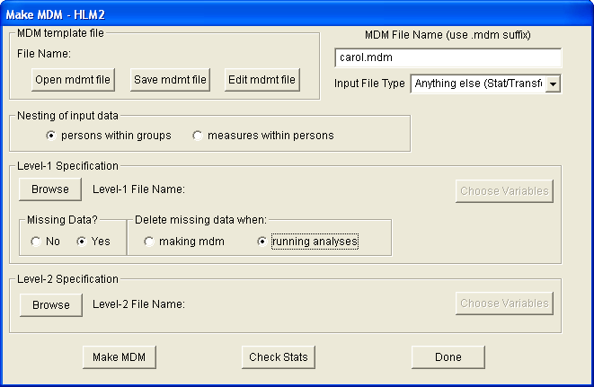
6) Choose your level 1 and level 2 files. **When you do, make sure to change the "Files of type:" at the bottom (back) to SPSS. (see below)
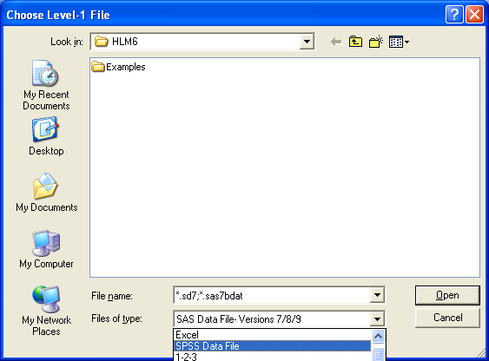
7) Choose variables. (Level 2 ID variable is the ID variable. Level 1 ID does not need to be included.) When in doubt, include it. Otherwise you have to remake the mdm going through this tedious process.
8) Change "Missing Data?" to yes "Delete missing data when" to running analyses. (see below)
9) Click on "Save mdmt file". Give it a name.
10) Click "Make MDM" (If it runs, it means everything was set up properly)
11) Click "Check Stats". Look it over to make sure everything looks how you want it to. Save the file. (I always save it as "descriptives".)
12) Click "Done"
Most centering is done when you are actually creating your analytic models.

