Running Interactions in HLM Software
Timothy W. Curby, PhD

Let’s say this is your (main effects) model, where gender (MALE), having closeness with the teacher (CLOSE), and the teachers’ emotional support (M_EMO at level 2) are predicting children’s sound awareness (S07A_SA).
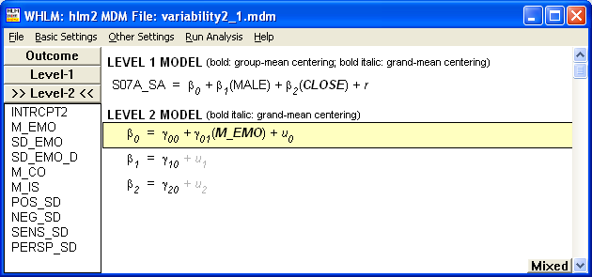

To run an interaction between males and the teachers’ emotional support, you add emotional support as a predictor to the Level-2 equation that corresponds to the Level-1 variable. So, in the above scenario, the effect of being male is B₁. So, add Emotional Support as a predictor to the Level-2 equation that begins with B₁.
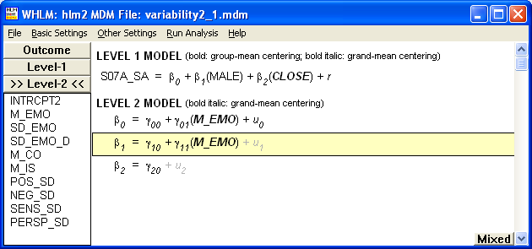

In terms of output, you’ll get something like this:
Final estimation of fixed effects
(with robust standard errors)
----------------------------------------------------------------------------
Standard Approx.
Fixed Effect Coefficient Error T-ratio d.f. P-value
----------------------------------------------------------------------------
For INTRCPT1, B0
INTRCPT2, G00 487.402745 1.395467 349.276 34 0.000
M_EMO, G01 1.961758 1.777621 1.104 34 0.278
For MALE slope, B1
INTRCPT2, G10 -0.841122 1.306990 -0.644 173 0.520
M_EMO, G11 -4.947517 2.393270 -2.067 173 0.040
For CLOSE slope, B2
INTRCPT2, G20 2.318725 0.890133 2.605 173 0.010
----------------------------------------------------------------------------

Notice that for Male, there is now an intercept (the main effect) and a value (under Male) for Emotional Support (the interaction). In this instance, neither main effect is not significant, but the interaction is.

